Multi-Server Java Application Build and Deployment Using Maven, Nexus, and Tomcat

Objective
The purpose of this task is to implement a complete multi-server deployment workflow for a Java web application using separate servers for build, artifact management, and deployment.
The workflow includes:
- Building the application using Maven
- Storing the generated WAR file in Nexus Repository
- Downloading and deploying the artifact on Apache Tomcat
This setup demonstrates a real-world CI/CD style deployment architecture where responsibilities are separated across multiple virtual machines.

Project Repository
Project used for this implementation:
Java Web Calculator App Repository

Architecture Overview
GitHub Repository
↓
Build Server (Maven Build)
↓
Nexus Repository Server (Artifact Storage)
↓
Deploy Server (Tomcat Deployment)
↓
Browser Access
The environment was created using three Ubuntu-based AWS EC2 instances.
Server | Purpose
Build-VM | Build Java application using Maven
Nexus-VM | Store WAR artifacts using Nexus Repository
Deploy-VM | Deploy WAR file on Apache Tomcat

Step 1: Build Server Configuration (Build-VM)

1.1 Launch EC2 Instance
- Create a new EC2 instance in AWS.
- Instance Name: Build-VM
- Operating System: Ubuntu
- Instance Type: t3.micro
- Enable SSH access (Port 22)

1.2 Connect to Build Server
Connect using SSH from local terminal.
ssh -i <key.pem> ubuntu@<public-ip>

1.3 Install Required Packages
Update packages:
sudo apt update
Install Git:
sudo apt install git -y
Install Java 17:
sudo apt install openjdk-17-jdk -y
Install Maven:
sudo apt install maven -y
Verify installations:
java -version
mvn -version
git --version

1.4 Clone Application Source Code
Clone the project from GitHub:
git clone https://github.com/mrtechreddy/Java-Web-Calculator-App.git
Move into project directory:
cd Java-Web-Calculator-App

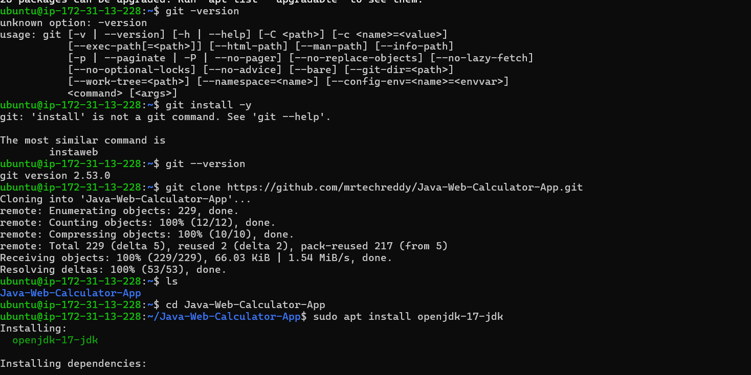

1.5 Build the Application
Run Maven build command:
mvn clean package
After successful execution, Maven generates a WAR file inside the target directory.
Check generated artifact:
ls target/
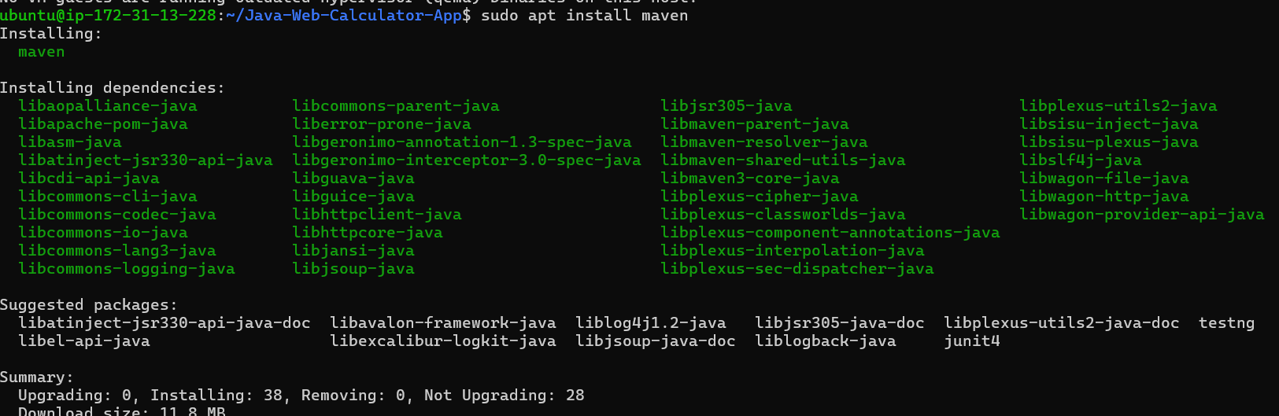
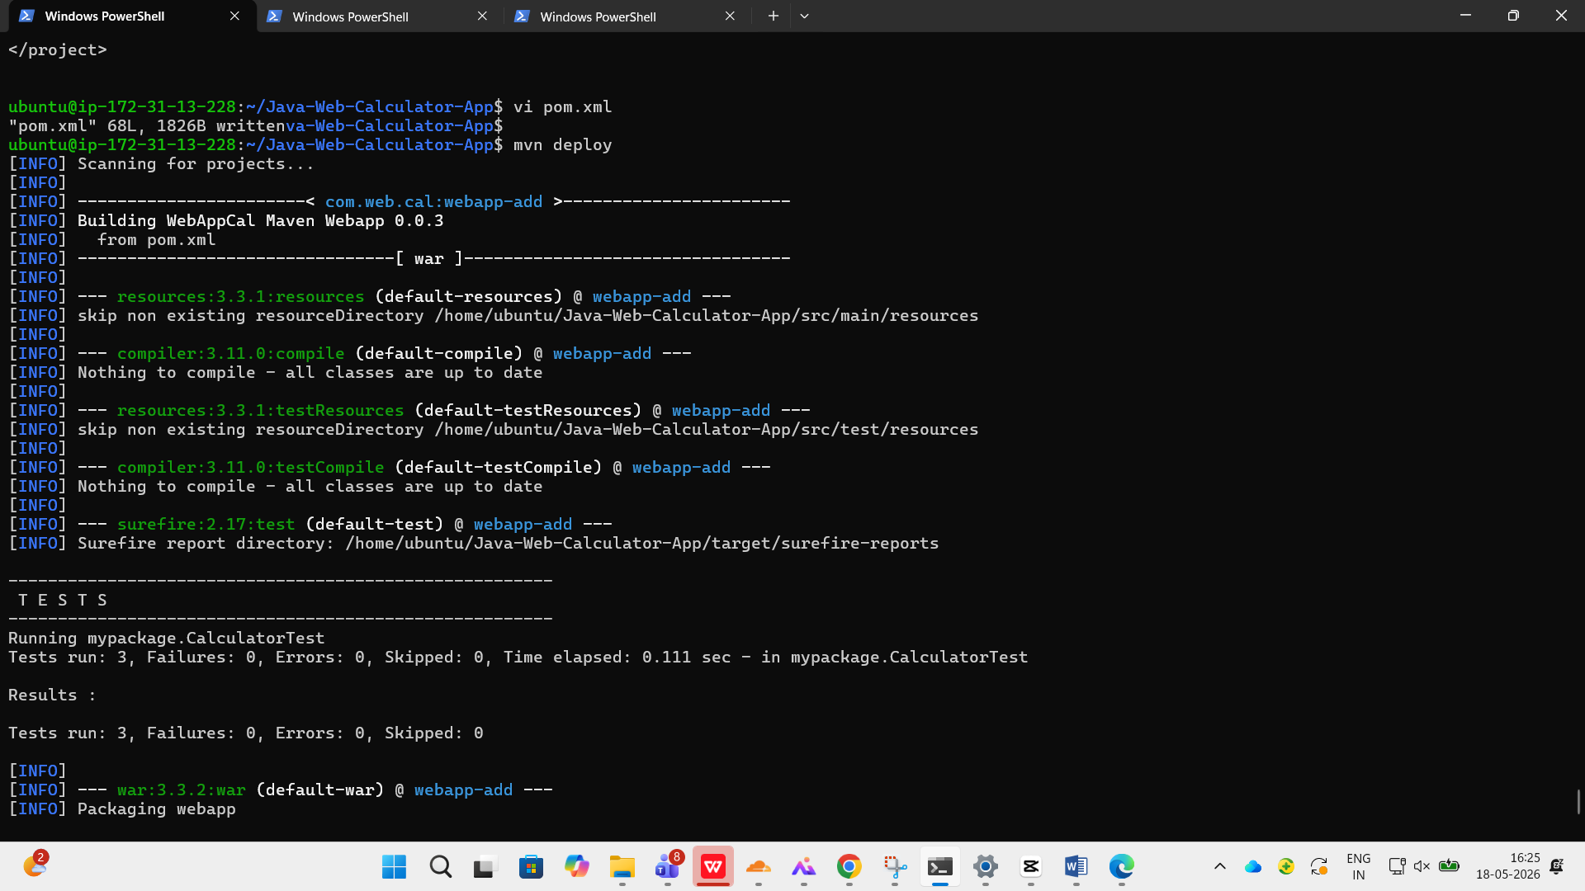

Step 2: Nexus Repository Server Setup (Nexus-VM)

2.1 Launch Nexus EC2 Instance
Create another EC2 instance with:
- Name: Nexus-VM
- OS: Ubuntu
- Instance Type: c7i-flex.large
- Open Ports:
  - 22 (SSH)
  - 8081 (Nexus)

2.2 Connect to Nexus Server
ssh -i <key.pem> ubuntu@<public-ip>

2.3 Install Java
sudo apt update
sudo apt install openjdk-17-jdk -y
Verify Java:
java -version

2.4 Download and Install Nexus Repository
Download Nexus:
wget https://download.sonatype.com/nexus/3/nexus-3.85.0-03-linux-x86_64.tar.gz
Extract package:
tar -xvzf nexus-3.85.0-03-linux-x86_64.tar.gz
Navigate to Nexus bin directory:
cd nexus-3/bin
Start Nexus:
./nexus start
Check status:
./nexus status
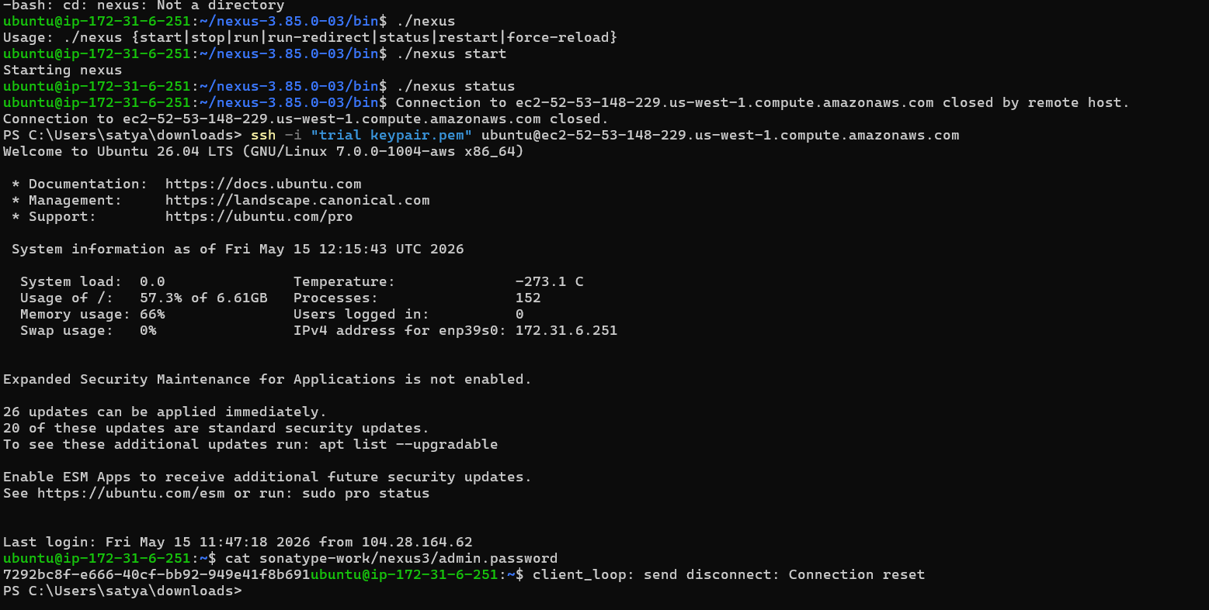

2.5 Access Nexus in Browser
Open browser:
http://<nexus-public-ip>:8081

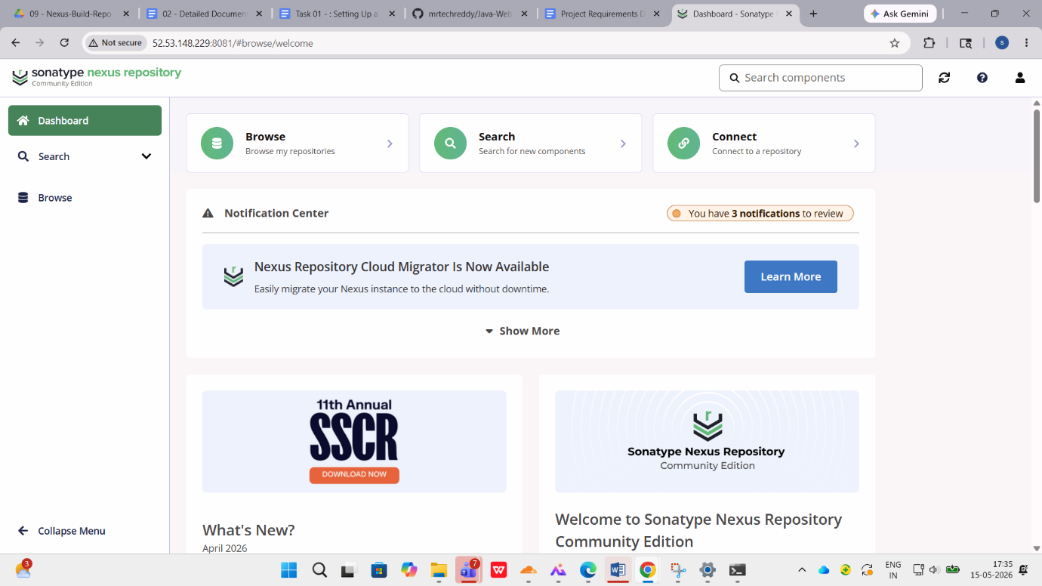

2.6 Retrieve Nexus Admin Password
Get initial admin password:
cat /home/ubuntu/sonatype-work/nexus3/admin.password
Login credentials:
- Username: admin
- Password: retrieved password
After login, update the password.

2.7 Copy Maven Repository URL
Inside Nexus:
- Open Repositories
- Select maven-releases
- Copy repository URL
Example:
http://<nexus-ip>:8081/repository/maven-releases/

Screenshot Placeholder
- [Insert Screenshot: Maven Releases Repository URL]

Step 3: Configure Maven for Nexus Deployment

3.1 Update pom.xml on Build-VM
Inside project pom.xml, configure distribution management.
Example:
<distributionManagement>
<repository>
<id>maven-releases</id>
<url>http://<nexus-ip>:8081/repository/maven-releases/</url>
</repository>
</distributionManagement>

3.2 Configure Maven settings.xml
Edit Maven settings file:
sudo vi /etc/maven/settings.xml
Add Nexus credentials:
<servers>
<server>
<id>maven-releases</id>
<username>admin</username>
<password>********</password>
</server>
</servers>

Step 4: Upload Artifact to Nexus
Deploy artifact using Maven:
mvn clean deploy
If deployment succeeds, the WAR artifact is uploaded to Nexus Repository.
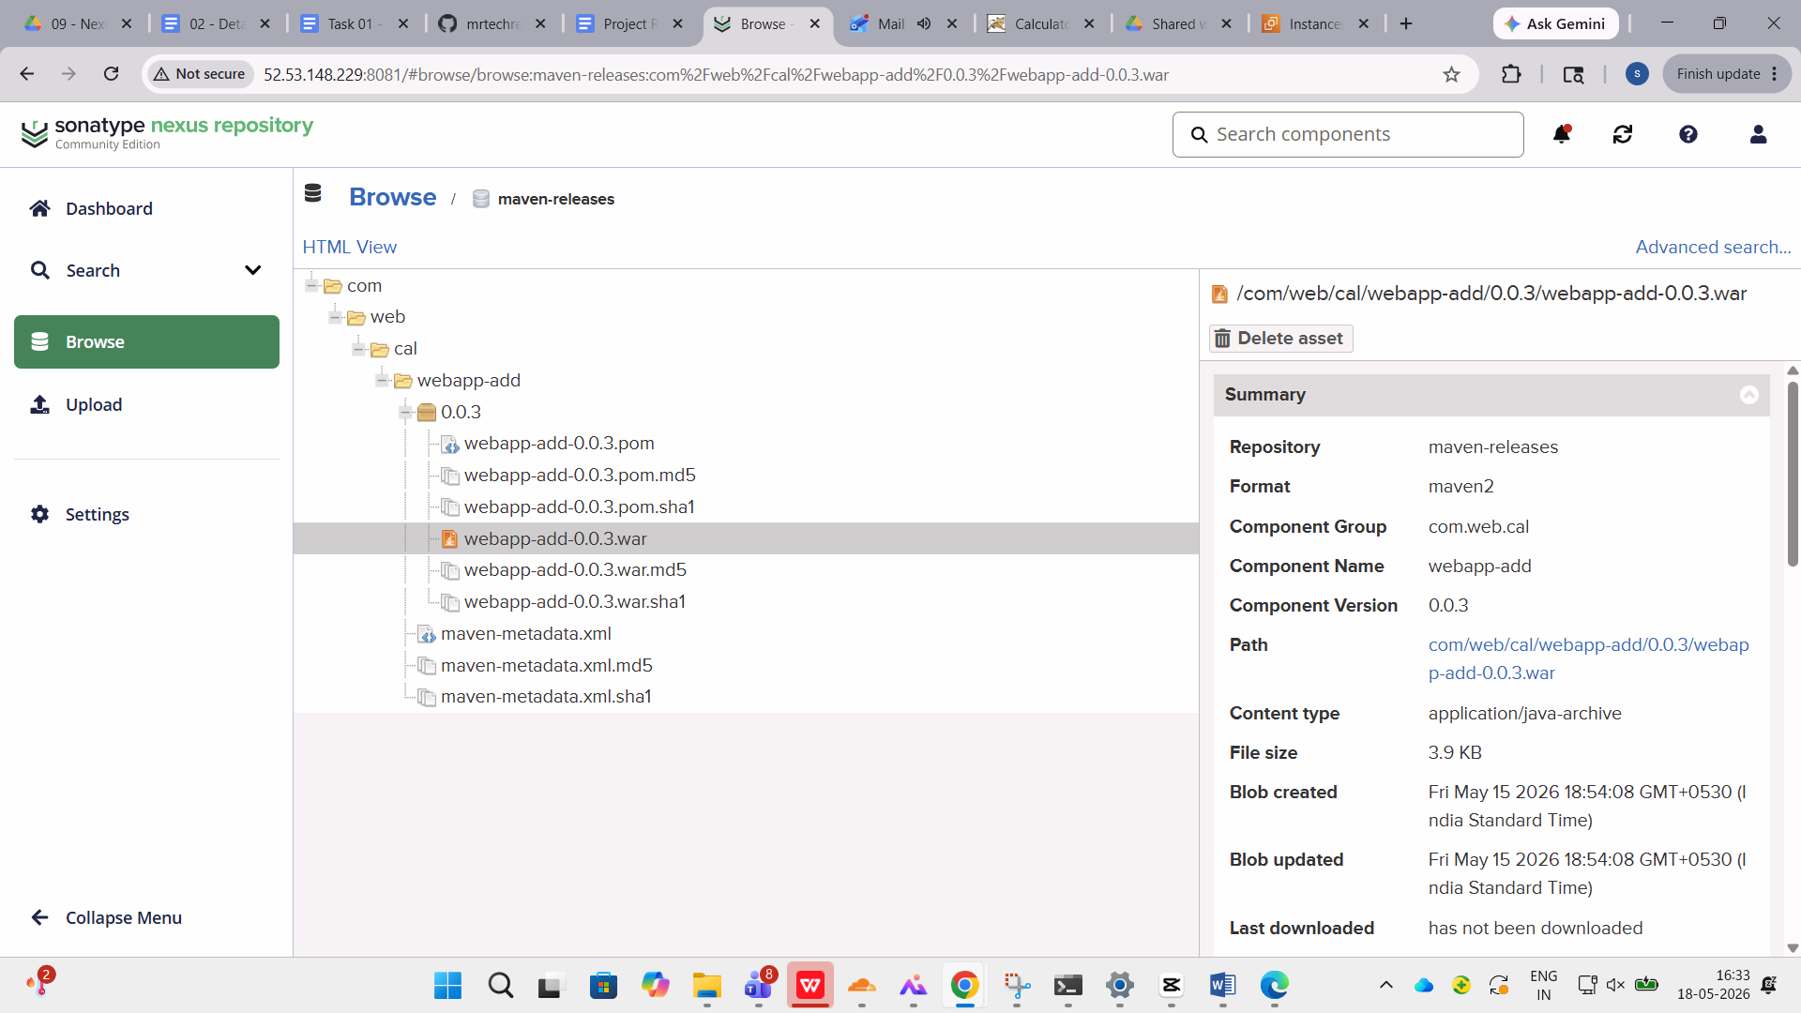

Step 5: Deployment Server Setup (Deploy-VM)

5.1 Launch Deploy EC2 Instance
Create another EC2 instance:
- Name: Deploy-VM
- OS: Ubuntu
- Instance Type: t3.micro
- Open Ports:
  - 22 (SSH)
  - 8080 (Tomcat)

5.2 Connect to Deploy Server
ssh -i <key.pem> ubuntu@<public-ip>

5.3 Install Java
sudo apt update
sudo apt install openjdk-17-jdk -y
Verify:
java -version

5.4 Install Apache Tomcat
Download Tomcat:
wget https://dlcdn.apache.org/tomcat/tomcat-9/v9.0.118/bin/apache-tomcat-9.0.118.tar.gz
Extract archive:
tar -xvzf apache-tomcat-9.0.118.tar.gz
Navigate to bin directory:
cd apache-tomcat-9.0.118/bin
Start Tomcat:
./startup.sh
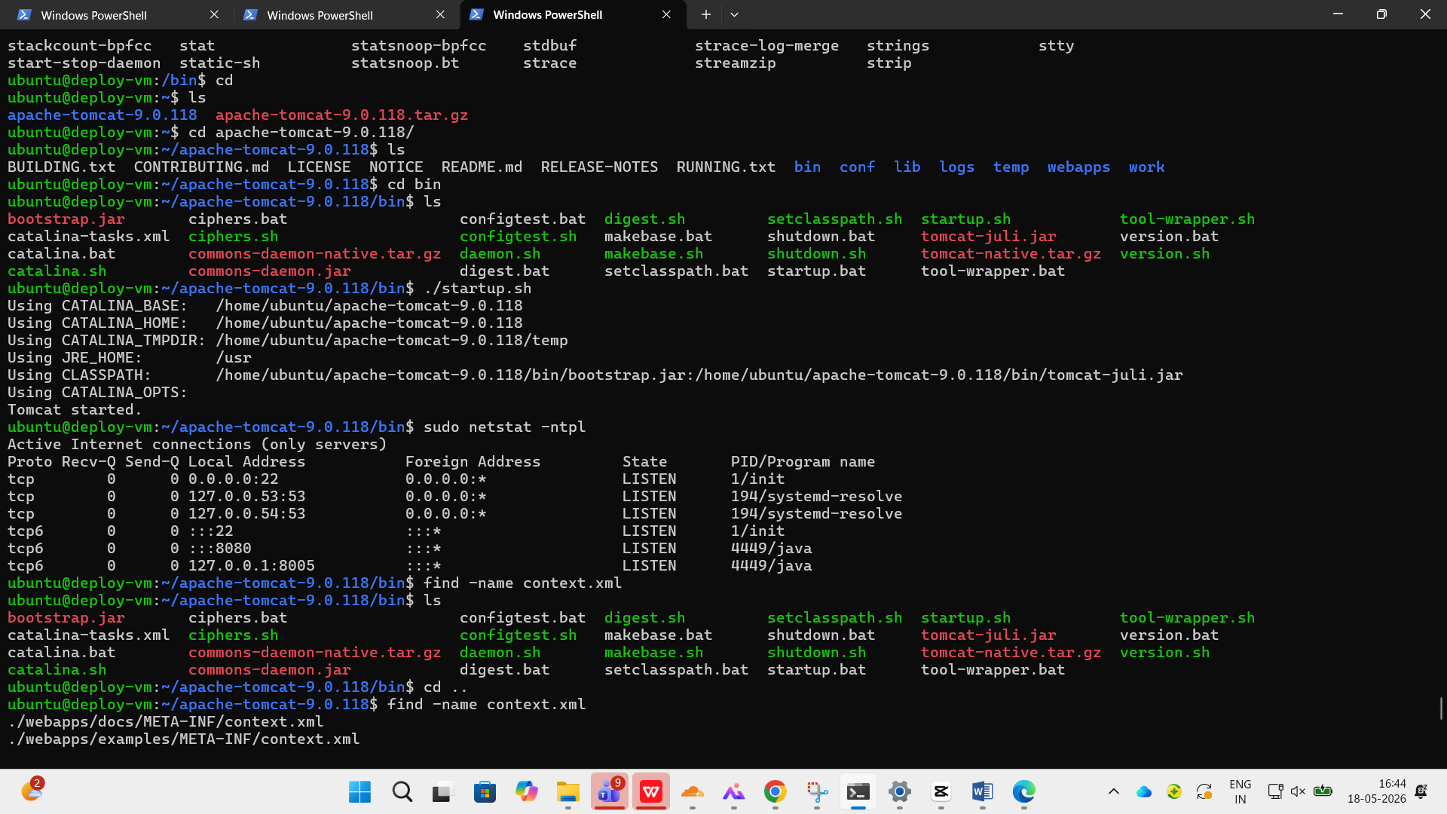

5.5 Configure Tomcat Users
Edit:
vi apache-tomcat-9.0.118/conf/tomcat-users.xml
Add credentials inside <tomcat-users>:
<role rolename="manager-gui"/>
<user username="admin" password="admin123" roles="manager-gui"/>

5.6 Download Artifact from Nexus
Navigate to webapps directory:
cd apache-tomcat-9.0.118/webapps
Download WAR file:
wget http://<nexus-ip>:8081/repository/maven-releases/<artifact-path>.war

Step 6: Application Deployment Verification
Tomcat automatically deploys the WAR file after download.
Access application in browser:
http://<deploy-server-ip>:8080/<war-file-name>
Verify calculator functionality by performing arithmetic operations.
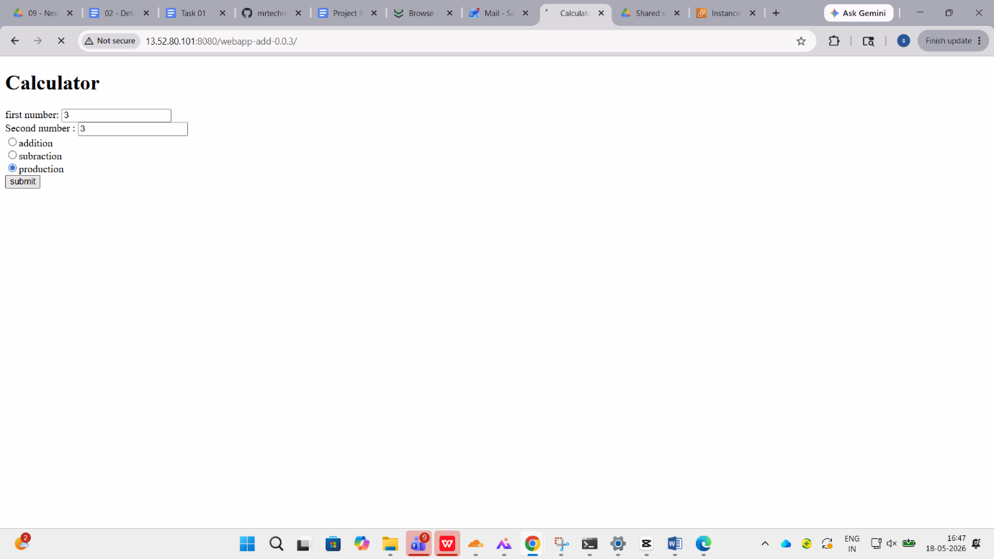

Final Outcome
The task was completed successfully by implementing a distributed deployment architecture using three separate servers.
The workflow achieved:
- Source code retrieval from GitHub
- Application build using Maven
- Artifact storage in Nexus Repository
- Deployment of WAR file on Apache Tomcat
This implementation demonstrates how build, repository management, and deployment can be separated into dedicated servers to simulate a practical DevOps deployment pipeline used in real-world environments.

